SALVAGE TENDER
2013 Lancair Evolution, N38DM, S/N EVO-0047
TENDER CONDITIONS
The salvage of the above aircraft is offered in a damaged condition for public tender, on an “as- is, where-is” with all faults basis subject to these Terms and Conditions and Salvage Tender Agreement. In particular, please read the section “Important Terms and Conditions” at the back of the Agreement.

Date of Loss: 10/01/2016

Aircraft Location: St. Peters Recovery and Storage in St. Peters, MO

Occurrence: Following an engine failure, the aircraft was forced to execute and off airport landing.

Bids shall be submitted no later than close of business on May 11, 2021 PST.

- Bids are to be in United States Dollars.

- The highest bid or tender will not necessarily be accepted.

- Once the successful Tenderer is notified that their bid has been accepted, the full purchase price must be deposited into a nominated account within Fifteen (15) days of that notification, at which point risk of all loss in the salvage shall pass to the Tenderer.

- The completion of the sale of the salvage and the transfer of title to the successful Tenderer will be subject to the execution of the form of FAA Bill of Sale by the Owner(s).

- Aircraft storage costs will be for the Tenderer’s account accruing from the salvage award date.

- McLarens Aviation, the Owner and/or Insurers make no representation whatsoever concerning the accuracy of information supplied, and the Tenderer acknowledges that regardless of whether they have inspected the salvage they are bidding on their own judgment of the condition of the salvage and records.

AIRCRAFT SALVAGE DATA

Year: 2013 Make: Lancair Model: Evolution N#: N38DM S/N: EVO-0047

Airframe Total Time: 360 (317 hours at Annual Insp. of 5/24/16).

Engine: Pratt & Whitney, PT6A-42, S/N PCE-93158, TT 317.0 (at Annual Insp. of 5/24/16)

Propeller: MT, MTV-76-7-E-C-F-R(P), S/N 720832, TT 317.0 (at Annual Insp. of 5/24/16)

Avionics Equipment:

1 ea. Garmin G1000
1 ea. TruTrak Sorcerer Auto Pilot
1 ea. Garmin Nav/Comm
1 ea. Audio Panel

AIRCRAFT DAMAGE DETAILS

The engine was broken in two and ripped from the firewall; all propeller blades from were broken. Both wings were torn open and the tail was torn from the aircraft.

Storage fee: $250.00 Per MONTH

Location of Avionics: In Aircraft

Title Search Complete: 10/27/2016

NOTE: Aircraft logbooks are missing; however, build records are accounted for. Bill of Sale and build records are with Mike Walker of McLarens General Aviation.

Contact Person: Mike Walker, 916-794-6047, mike.walker@mclarens.com

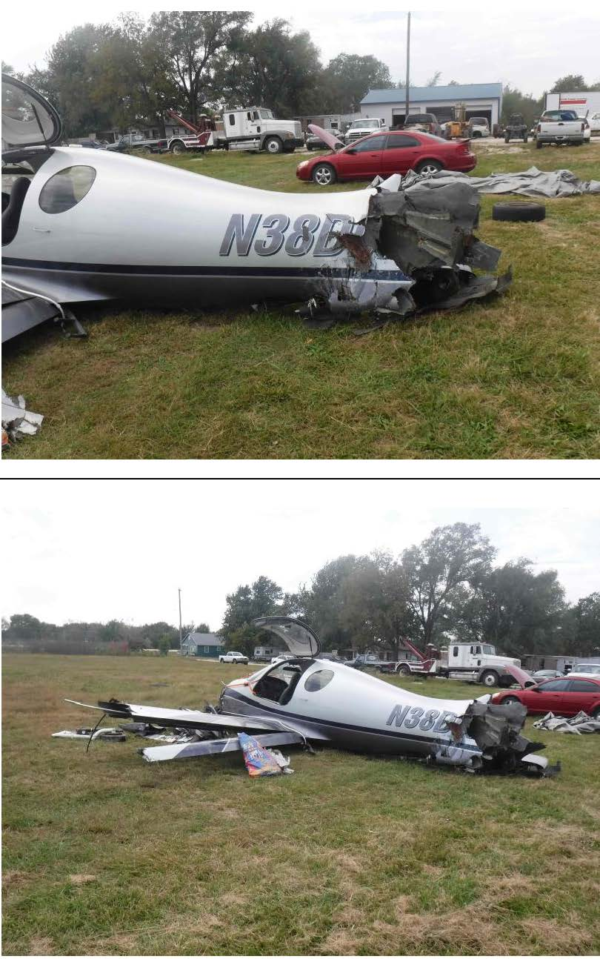
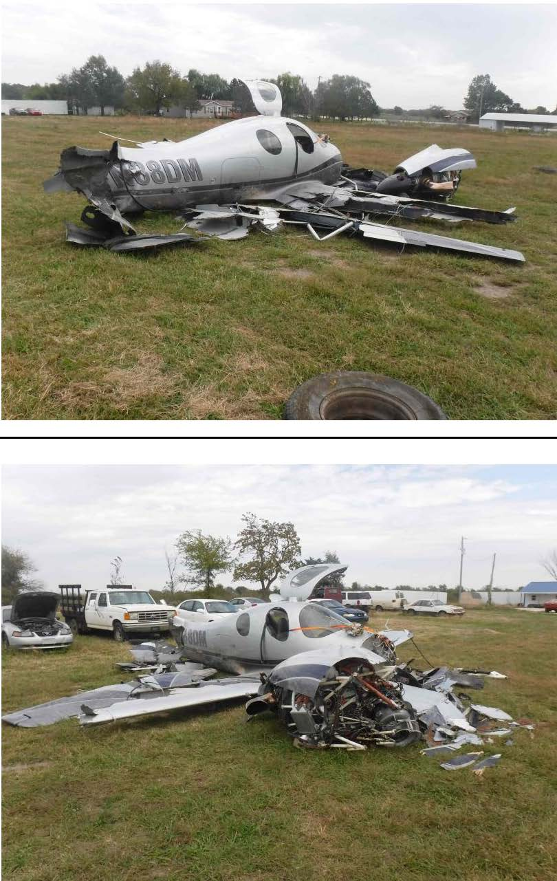

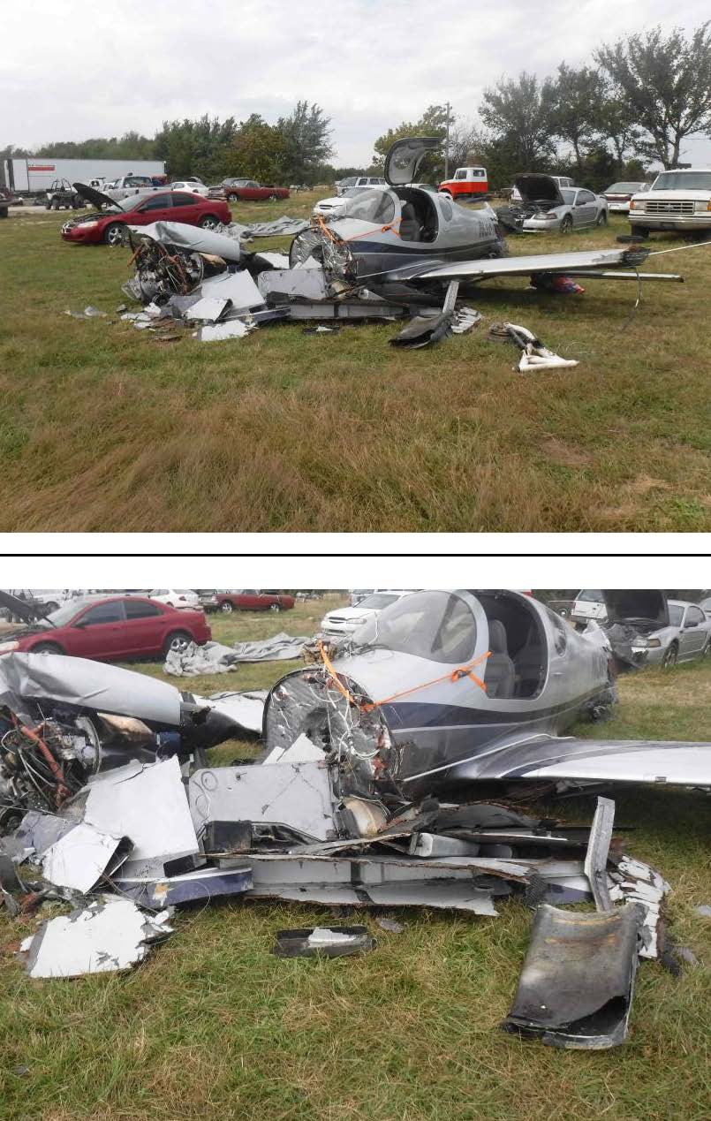

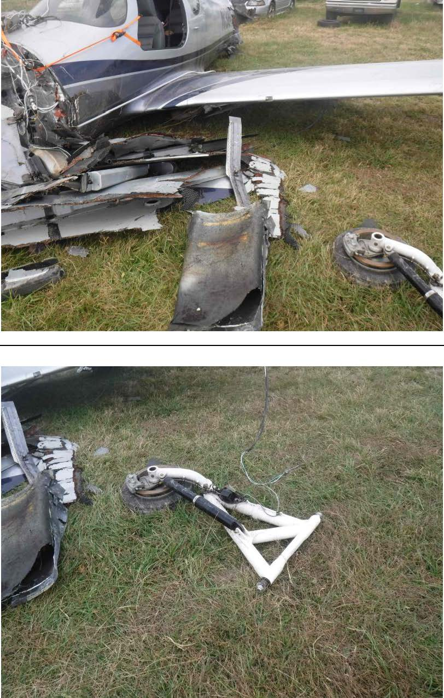

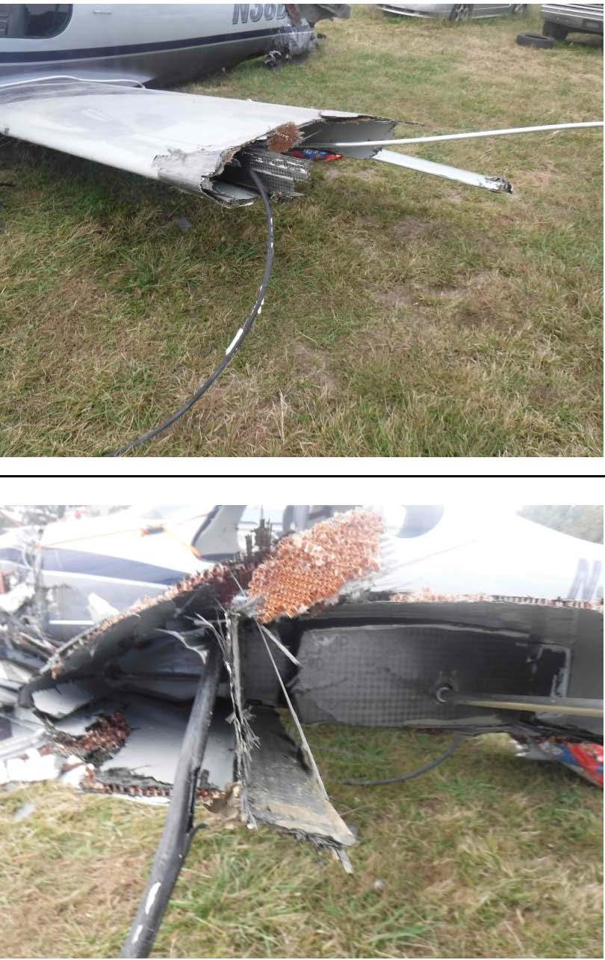

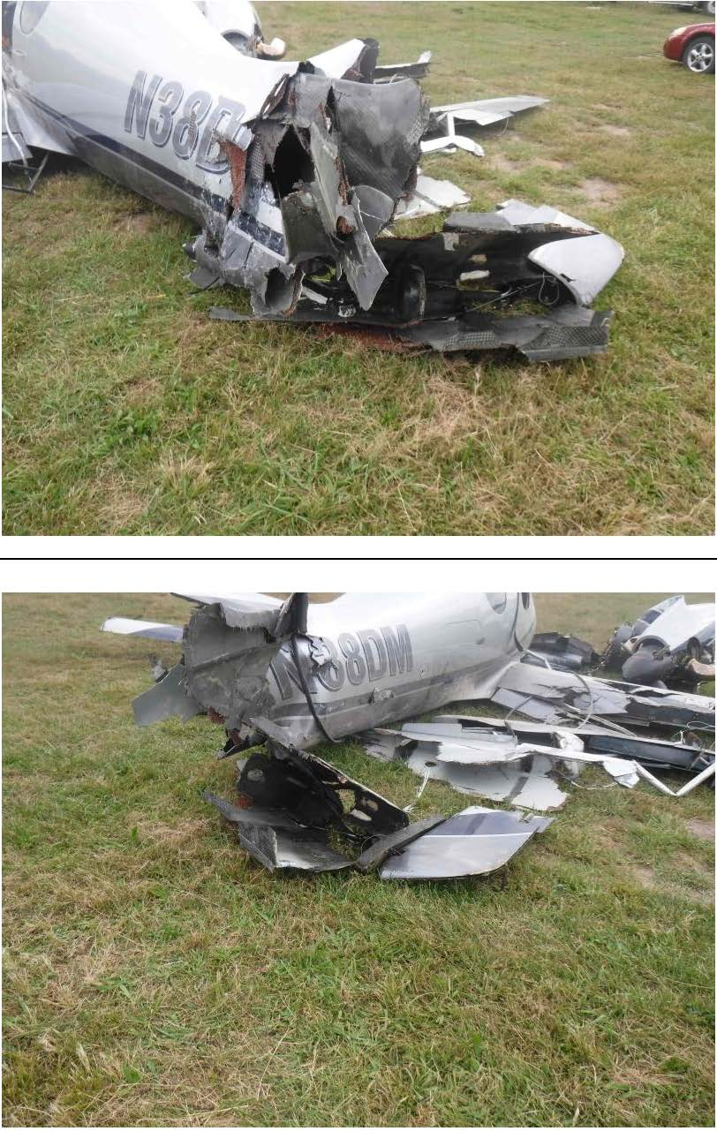

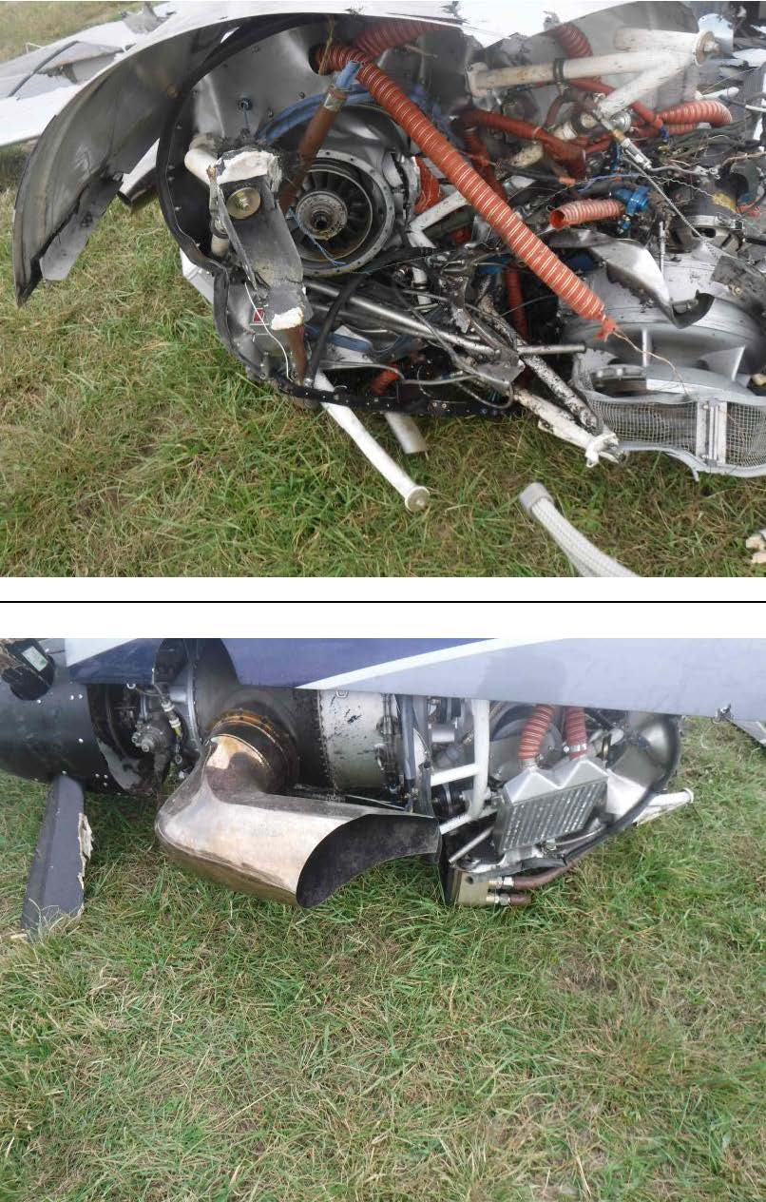

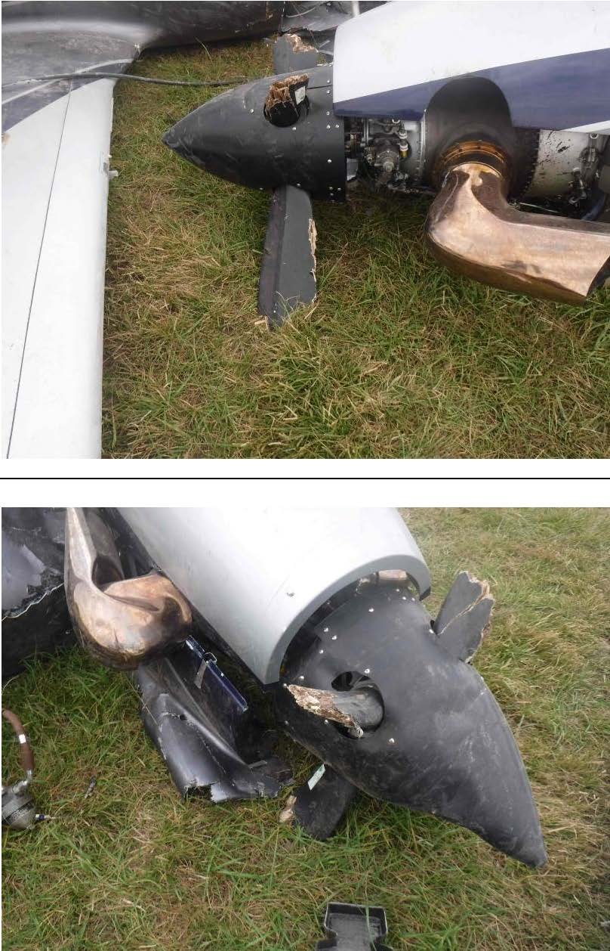

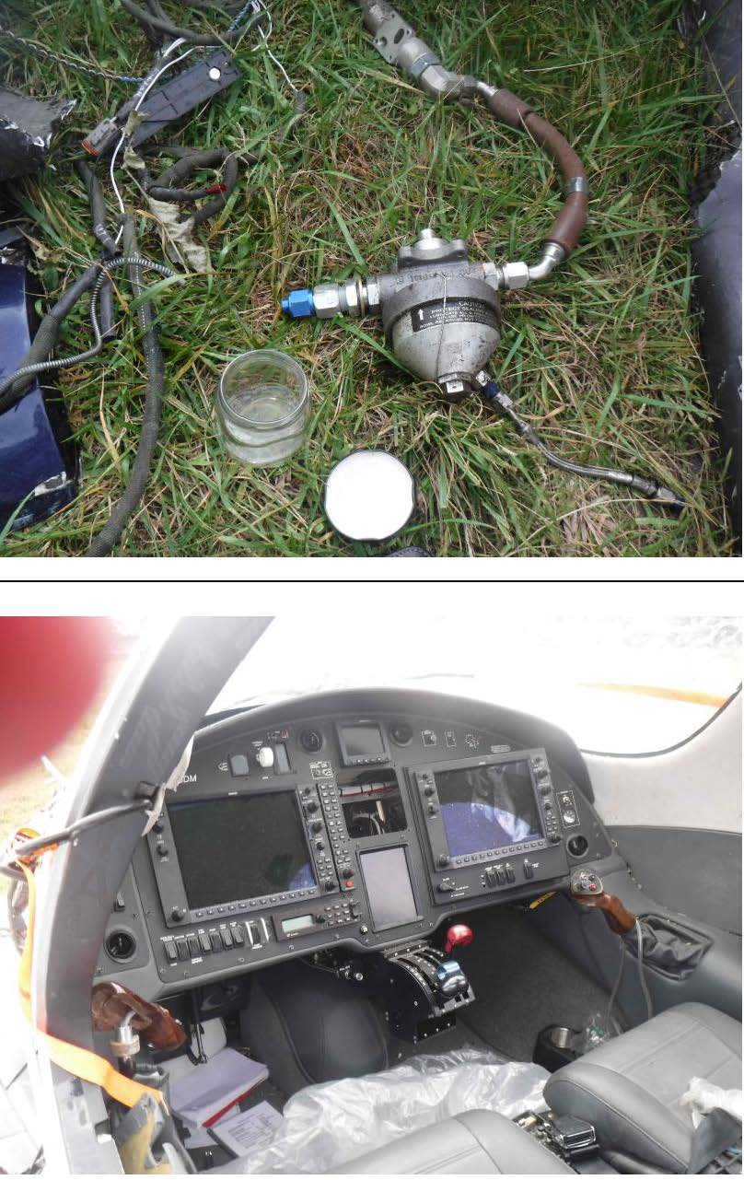

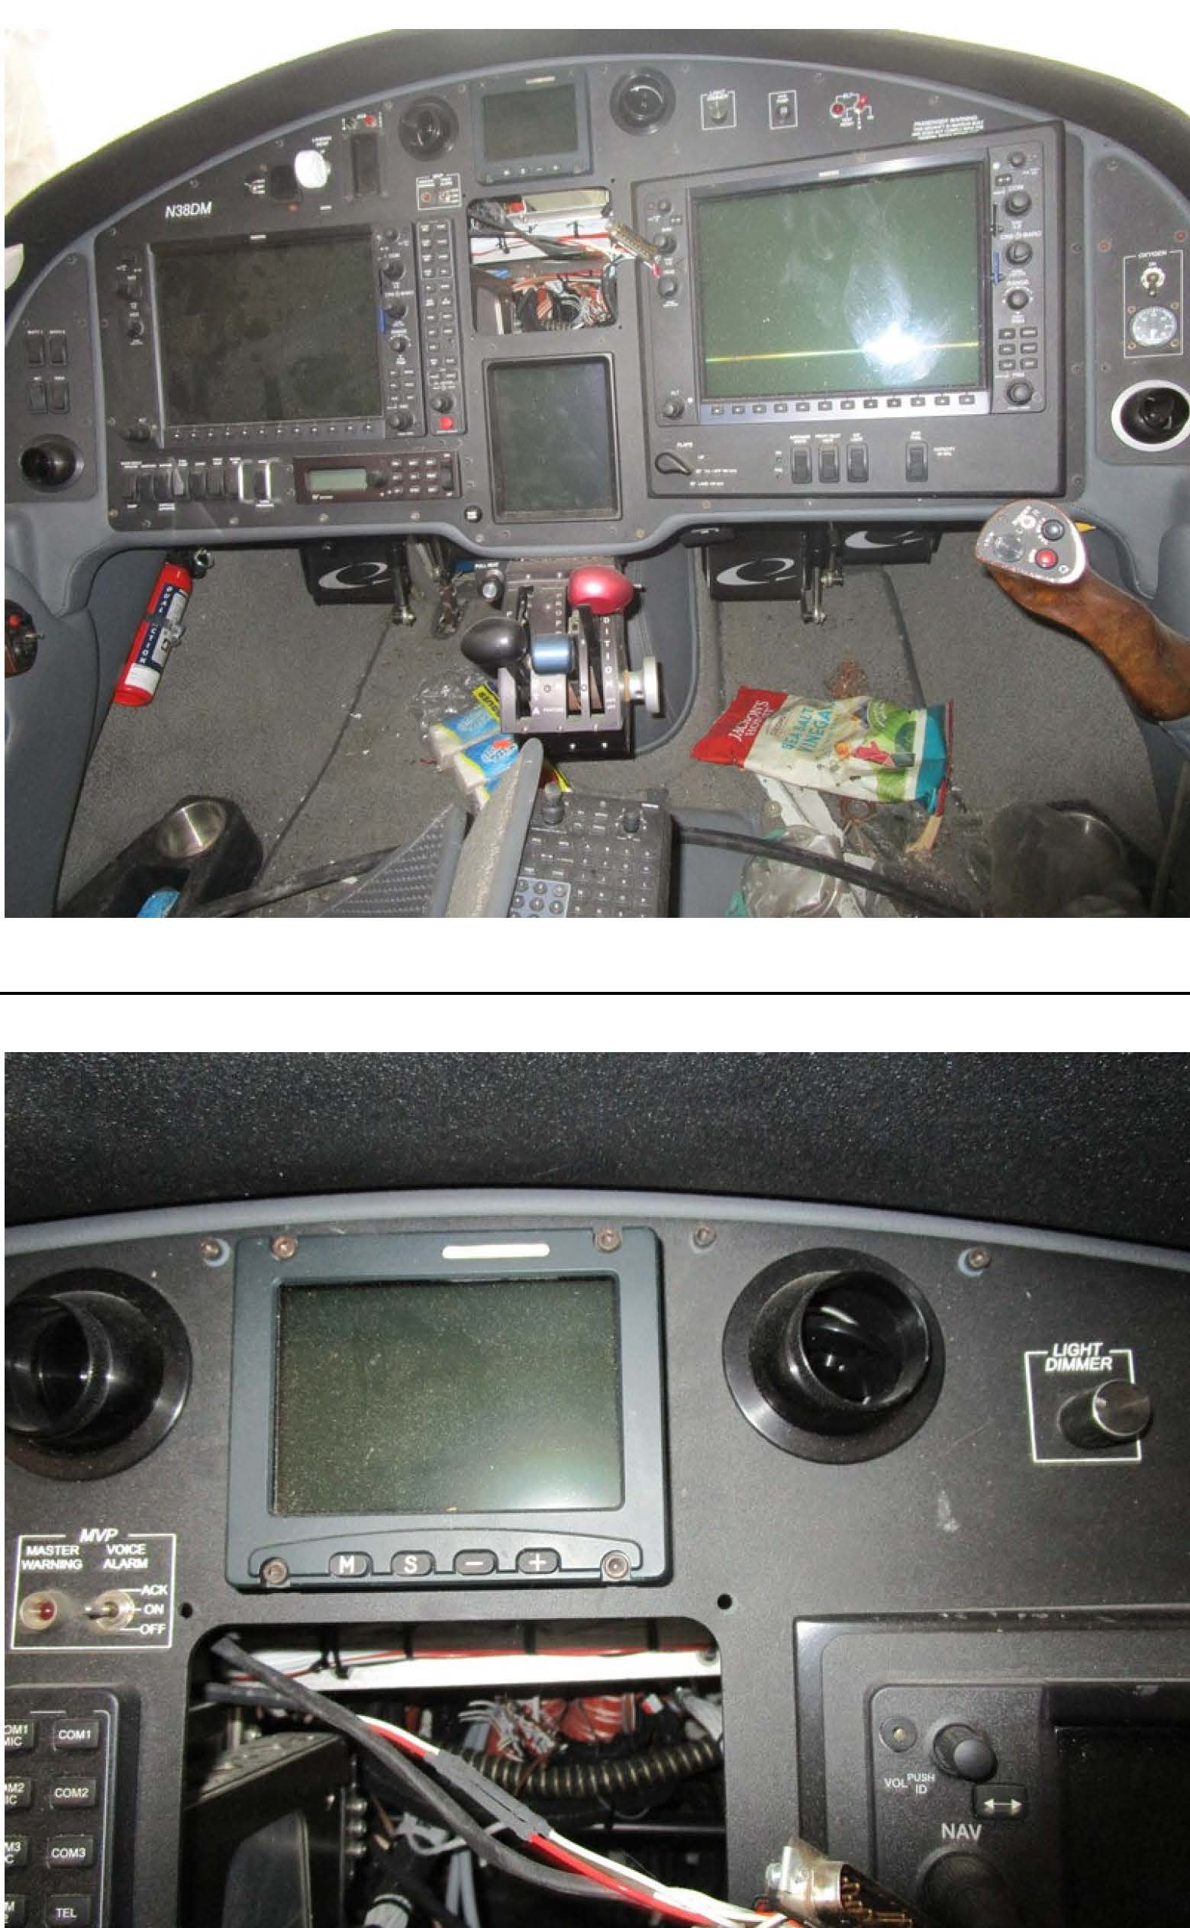
IMPORTANT TERMS AND CONDITIONS

EXCLUSIONS

- By placing a bid you accept and understand the following: that the salvage including wreckage and/or parts and/or documents and/or any other item sold pursuant to this Agreement are sold on an “as is, where is” with all faults basis and neither MYI Limited, trading as McLarens Aviation, nor the owner nor Insurers give any warranty, including any statutory warranties, or makes any express or implied or statutory representation as to the status or condition of the salvage or its suitability or fitness for any purpose or use whatsoever. For the avoidance of doubt, all terms implied under the Sale of Goods Act are excluded from this Agreement.
- Neither MYI Limited, trading as McLarens Aviation, nor the owner nor Insurers shall have any liability or obligation whatsoever in respect of the salvage sold. In particular, any liability or obligation in tort, whether arising from negligence or otherwise, or in contract, express or implied pursuant to any statute or regulation for any losses whatsoever including but not limited to any direct or indirect or consequential losses, expressly arising from the purchase or subsequent use of the salvage.
- The salvage is incident related and therefore MYI Limited, trading as McLarens Aviation, the owner and Insurers DO NOT warrant that the salvage is airworthy or serviceable.
- In the event that your bid is accepted you warrant and undertake that the salvage shall be overhauled and recertified before it enters service (revenue or otherwise) in accordance with good aviation practice and any party undertaking such overhaul and recertification shall be made fully aware of the incident.
- These exclusion provisions apply equally to purchases or users within the USA or outside of the USA.

INDEMNITY / HOLD HARMLESS

In the event you are the successful bidder, you undertake on behalf of yourself and any other party you are bidding on their behalf to indemnify and hold harmless MYI Limited, trading as McLarens Aviation, the Owner, Insurers and their employees, agents, assignees and shareholders, directors, officers and subsidiaries from and against any and all future claims arising out of the use of or existence of the salvage for any purpose in any jurisdiction whatsoever.

SEVERABILITY

Any clause of this Agreement which is declared unlawful, void or unenforceable by any competent authority or court with jurisdiction over this Agreement shall, to that extent, be deemed severed. All other provisions of this Agreement shall continue unaffected and remain in full force and effect.

Further I/we agree that we will make the necessary arrangements to have the Salvage storage and /or removal complete within fifteen (15) days of transfer of title to us the successful bidder.

GOVERNING LAW AND JURISDICTION

This Agreement and its interpretation shall be subject to the law of the State of Missouri, U.S.A.

